CIRCUIT: -

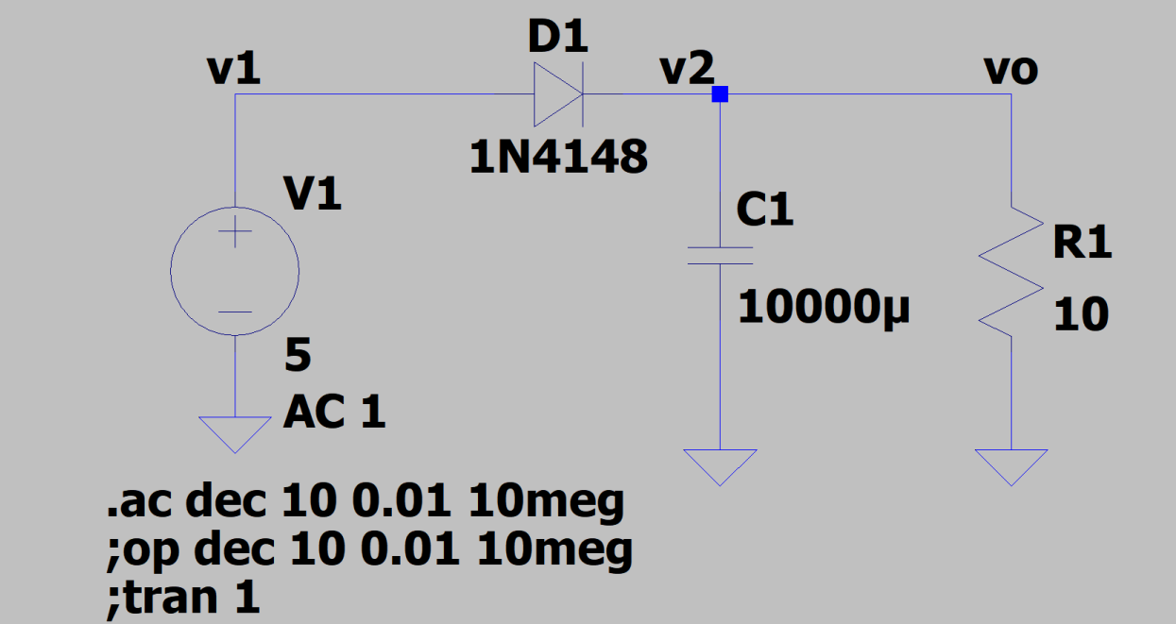

OUTPUT GAIN:

FREQUENCY:

